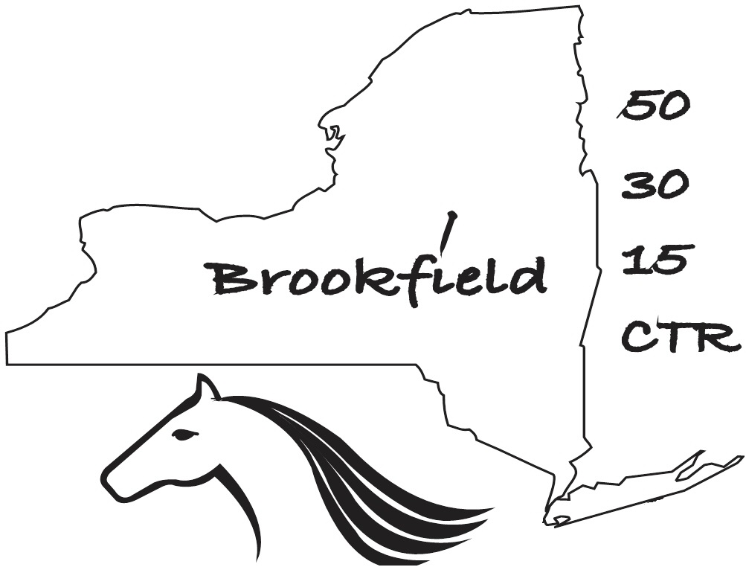Brookfield 50/30/15
Competitive Trail Ride
June 23-June 25, 2017
wwww.BrookfieldCTR.weebly.com
Held at Pure Country Campgrond
New Berlin, NY
NO Blacktop --- ZERO!
Rider

Name______________________________________________________Jr._______Sr.______
Address___________________________________________________Age if Jr._________
City______________________________State_____Zip_________Tel #_________________
E-mail_____________________________________________ECTRA #___________________
I am entering: Optional Pass/Fail
  - 50 Mile ride June 24, June 25, 2017
  - 30 Mile ride June 24, 2017
  - 15 Mile Conditioning Distance Ride June 25, 2017
Is this your first competitive ride? _______________
Length of rig being brought:_____________________
Horse
Name_____________________________________ECTRA#___________________________
Breed_____________________________________Reg. #_____________________________
Age__________________________Sex____________________Color____________________
Coggins enclosed__________ (current year) Rabies enclosed__________ (current year)
Is this your horse’s first competitive ride? _______________
Owner
Name___________________________________________________________________
Address______________________________________________________________________
City___________________________State_____Zip_________Tel. #___________________

This liability release and agreement must be signed and returned with your entry. No cross outs or additions are permitted.

In consideration for permission to enter and participate in the New York 50/30 Mile Competitive Trail Ride and 15 Mile Conditioning Distance Ride, I do hereby for myself, my heirs and assigns, release and hold harmless Ride Management, Ride volunteers, NYS-DEC, NYSHC, ECTRA, Pure Country Campground and their agents, officers, servants, employees and officials, from all claims, demands, actions and causes of action of any kind, for injury or death sustained by me or my horse, and damage to my property, incurred during this ride arising from negligence or any other fault. “Ride” includes from the time my horse and I arrive at base camp until the time that we leave the premises, as well as the actual event. “Horse” means the animal I am riding or have entered.
I understand that horseback riding is an inherently dangerous activity and am aware that 1. The ride involves being in areas for extended periods of time not close to communications, transportation, medical and veterinary assistance; 2. That these areas have natural and man-made hazards, which Ride Management cannot anticipate, modify or eliminate; 3. That both my own horse and those of other participants can be excitable, difficult to control and unpredictable, and can panic, bite, rear, kick, strike, stumble or fall; 4. That as a result of participating in the ride my horse or I may be injured, die or my property damaged.
In the event that the Rider/participant initiates a lawsuit against ride management, ride volunteers, NYS-DEC, NYSHC, ECTRA, and their agents, officers, servants, employees and officials as a result of his/her participation in the ride, and said Rider/participant fails to establish liability or fault of the above-named entities, the undersigned agrees to pay all litigation costs and legal expenses incurred by the above-named entities in defending said lawsuit. It is further agreed that the above-named entities may assign their right to recover legal fees and expenses to their insurance carrier.
I agree to take full responsibility for my horse and myself. I recognize that the ride is a strenuous activity and I represent that my horse and I are in adequate physical and mental condition to participate. I recognize that my participation in the ride is voluntary. I agree to wear certified (ASTM Fl 163/SEI) protective headgear at all times when mounted throughout the ride. In addition, my participating equine will have a current 2017 negative Coggins test, and will be properly vaccinated against rabies. I also consent to a drug test upon my horse if requested.

I HAVE READ AND UNDERSTAND THE ABOVE LIABILITY RELEASE AND AGREEMENT, AND AGREE TO BE BOUND BY ITS TERMS AND CONDITIONS.

Rider’s signature _____________________________________________________________

Guardian signature (if Junior) ________________________________________________

Owner’s signature _____________________________________________________________

FEES
This fee covers camping for all horses from Friday, June 23th to Sunday, June 25; drug-testing fee; continental breakfast, snacks at hold and chicken barbecue on Saturday for 50 and 30 milers; additional continental breakfast on Sunday for 50 milers; Chicken barbecue dinner on Saturday and continental breakfast on Sunday for 15 mile CDR riders; There is an enclosed dining room and bathroom with hot showers on site. Larger breakfasts or lunches are available for purchase on site.

RIDER’S ENTRY FEE $160 for 50/ $125 for 30/ $105 for 15 milers
DEDUCT FOR NYSHC MEMBERSHIP (-$10, include proof)- ________
DEDUCT FOR ONE RIDER ENTERING HORSES IN 30 AND 15(-$15)-------- ________
DEDUCT FOR JUNIOR RIDER (17 AND UNDER) 50--$20, 30--$15, 15--$10 - ________
BALANCE DUE FOR ENTRY ____________

MEALS for non-RIDERS (volunteers eat free on day they work, this includes continental breakfast, bag lunch & Sat. dinner)
Cost Number Amount

GUEST SAT. Chicken BBQ complete buffet $ 15 _____ _______

GUEST BREAKFAST SAT. CONTINENTAL BREAKFAST $ 5 _____ _______

GUEST BREAKFAST SUN. CONTINENTAL BREAKFAST $ 5 _____ _______

NOT INCLUDED IN ENTRY FEE

LATE FEE (Received after June 05) $ 25 for 50 miler _______
$ 15 for 30/15 miler _______

GRAND TOTAL _______________

MAKE CHECKS PAYABLE TO: Dan Gruen, NY 50/30

DEADLINE & REFUND POLICY

Entries will be accepted up until June 20, BUT IF THERE ARE NOT ENOUGH ENTRIES TO FINANCE THE RIDE, THE RIDE WILL BE CANCELED ON June 1 so please sign up before this date if at all possible. Full refunds up to June 1. Refunds after June 1, if there is a replacement horse or at the discretion of the management depending on expenses. After June 1, a surcharge of $25 will be added to 50 mile and $15 to 30/15 mile entry fees.

I would like to ride with: __________________________________________________

DIRECTIONS
GPS directions include poor dirt roads. Map and alternate turn by turn directions are at: www.purecountrycampground.com. Address is: 176 Kelly Rd., New Berlin NY 13411
Near the top right of the page is a login oval. Just below and left of this is the word directions. Click this link to get to the next page. Scroll down to the bottom of that mostly blank page and click the small sentence that says, “Click here to get turn-by-turn driving directions.” This will take you to a map and directions page. Insert your starting point then click search. It will give you good directions to the campground.
Or you may request general directions from Joanna.
** REQUEST FOR VOLUNTEERS **
We need lots of volunteers to keep this ride going. If you have a spouse or friend who would like to come along and volunteer, please bring them! If you are riding the 30 or the 15, consider spending the weekend and volunteering on the alternate day. Additional food, fun, campsite and camaraderie are free. Great training for Newbies! All volunteers please register with the Ride Secretary, Joanna Lasher.

Brookfield 50/30/15
2017 RULES AND GENERAL INFORMATION
This competition is sanctioned by the Eastern Competitive Trail Riding Association. Rules may be found at www.ECTRA.org. Please read them before you come to the ride.

Please review the rules on the web site for information on RIDE TIMES, JUDGING, TRAIL CONDUCT, ELIGIBLE HORSES, MEDICATIONS, SHOEING, LEG PROTECTION etc.

The ride is sponsored by the New York State Horse Council. www.NYSHC.org Please become a member.

Pot Luck Dinner
Dinner Friday will be a pot luck supper. Please bring a dish to pass.

RIDE DATES
The 50-mile ride will take place Friday June 23-Sunday June 25. Pre-ride exams will be available starting at 3:00 PM and continuing until 6:00 PM. Prior arrangements for late vetting must be made with the Ride Secretary: jolasher65@gmail.com or 518-882-1515 at home or 518-577-9638 cell.

The 30-mile ride will take place from Friday June 23- Saturday June 24. Pre-ride exams will also be available starting at 3:00 PM and continuing until 6:00 PM. See above regarding late vetting arrangements. Non-camping riders and horses will need to be on site by 6:00AM of ride day.

The 15-mile ride will take place Saturday June 24-Sunday June 25. Pre-ride exams will be available starting at approximately 3:00 PM following the vetting out for the 30 milers. Non-camping riders and horses will need to be on site by 7:00AM of ride day.

COGGINS & RABIES
A negative Coggins certificate is required for each horse. This certificate must be dated 2017. A copy should accompany the entry form; otherwise it must be presented to ride personnel before horse may be unloaded. All horses will also be required to have a 2017 rabies vaccination.

DIVISIONS
Juniors will ride as a separate division.

Waiting list
In the event that the ride fills, a waiting list will be maintained; those entrants will be notified of an opening ASAP.

Trails
Trails consist of forested woods trails and hard packed dirt truck trails. There are No Paved Roads. There are many hills. All trails will be plainly marked. Mileage markers are placed every 5 miles and every mile in the last 5 miles to assist in timing. Any horse that leaves the marked course by mistake or any other reason must re-enter the course at the same point from which it left. Time consumed by such digression must be included in the rider’s total elapsed time. Except for safety reasons, riders may not at any time dismount and proceed on foot. Because some areas are rocky, shoes are recommended.

Pre-Ride Briefings
Pre-Ride Briefings and Newbie Meetings will be at dinner both Friday and Saturday night. All riders are strongly encouraged to attend.
TRAIL CONDUCT
A rider should not pass in an unsafe area, should ask to pass, and should pass at a gait other than a canter or gallop.

OTHER
- Any tack is permitted. Riding bareback will not be permitted.
- Riders should bring buckets, hay net, blankets, hay, feed, and cleaning tools.
- A competing rider may not be accompanied by a non-competing rider from crossing the starting line to crossing the finish line.
- All entrants disqualified for any reason wishing to exercise their horses on the trails must receive permission from management.
- Dogs MUST be tied-up, safely contained, or held on a leash at all times.
- Portable paddocks are allowed at the campsite.
- ALL riders will be required to wear ASTM/SEI certified protective head gear designed for equestrian use at ALL TIMES whenever mounted!

Judges this year are:
- Dr. Nick Kohut--Gap, PA
- Eva Norris--Port Crane, NY
- Dr. Ann Chaffee--Ithaca, NY is our treatment vet.
- Our farrier is Jeff Walker--West Winfield, NY.

Put these dates on your calendar:
- June 1 is a crucial date if you must cancel from the ride. Before this date your entry fee will be refunded.
- Ride closing date is June 20 — no entries accepted after this date.
- Verizon cell phones function at the campground.
- Medical, Fire, or Police EMERGENCY 911
- Madison County Sheriff 315-366-2311
- Chemung County Sheriff 315-737-2987

Happy Conditioning,
Dan Gruen, Ride Manager Joanna Lasher, Ride Secretary

Please return the following to:
Joanna Lasher 2292 Hermance Rd. Galway, NY 12074
Phone: (518)882-1515(call or messages) Cell (518)577-9638(call or text)
E-Mail jolasher65@gmail.com
- Completed and signed entry application page 1
- Signed liability release page 2
- Completed entry page 3
- Payment in full — Make checks payable to Dan Gruen, NY 50/30
- Copy of this year’s, 2017, negative Coggins Test
- Proof of 2017 Rabies vaccination
*** All reservations for your rig site with or without water and electricity or pipe stalls (30&15 milers only) must be made with Jim Weidman, Owner/Manager Pure Country Campground (PCC) at 607-847-9265, See Web Site: www.purecountrycampground.com
All those bringing a rig must contact PPC promptly after submitting their entry. ***
Confirmation of your entry will be by e-mail.

